User Manual: Quarantine Status

| December-20 |

**Document Overview**

**Documentation Goals**

This documentation is intended to provide instruction for ***(configuration of the SS Tag Status for Load Tag Quarantine)****.*

**Documentation Disclaimers**

* Teach a user how to configure the N-K-1 SSTagStatus control parameter.
* Provide instructions for how to use the various configuration settings for Load Tag Quarantine.

**Table of Contents**

**Overview** 2

**Configuration** 2

[N-K-1] SSTagStatus 2

Parameters 2

[I-F-9] Inventory Status Type 3

[B-F] Sharp Shooter – Update Tag Status 3

# **Overview**

Load Tags with a *Quarantine* status will be excluded from current inventory counts until their status has been updated out of quarantine.

# **Configuration**

## [N-K-1] SSTagStatus

This *System Control Parameter* sets the default status of Sharp Shooter tags.

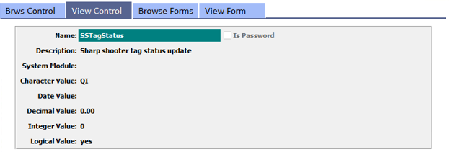

### Parameters

#### Character Value

This can be defaulted so that the user cannot enter any tag status, and the default here forces the tag to be updated with this status automatically. If left blank, then the user will be prompted for the tag status to apply. For example, if the tag status is forced to be *'001' - Quarantine*, then the value will default to the defined status.

#### Logical Value = “Yes”

This allows the user to scan a tag that is already on hold and adjust the status. If the pallet tag that is scanned has a status of “*On Hold”*, the user will be permitted to enter a status change.

#### Logical Value = “No”

This will not allow the user to change the status that is already on hold, and will show them a message that this tag is on hold and cannot be used. If the pallet tag that was scanned has a status of “*On Hold”*, then the user will be prompted with zMessage (55) indicating the tag is on hold and will display the tag status in the zMessage.

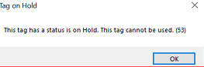

If the tag is not on hold, then the system will look at the [***“N”-“K”-“1”]*** *SSTagStatus* *Character Value*. Once scanned, whether updated or not, the program will add to the scanned list of tags on the screen.

## [I-F-9] Inventory Status Type

The *Inventory Status Type* located at Hot Key sequence ***[“I” – “F” – “9”]*** will show the user a list of all of the currently available *Status Codes*.

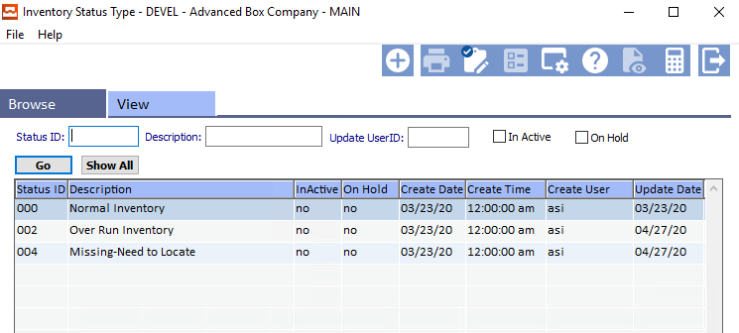

## [B-F] Sharp Shooter – Update Tag Status

Under the *Sharp Shooter – Finished Goods*, located at Hot Key sequence ***[“B” – “F”]*** the button entitled ***“Update Tag Status”*** allows a user to scan a tag and, optionally, enter a status code to a tag.

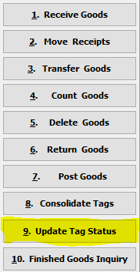

When the user clicks the ***“Update Tag Status”*** button, they will be prompted to scan a tag number. Then the program will show the current status of the tag based on the tag number, and the quantity (if it is not zero).